Name:____________________
Can you put the correct number of leaves on your tree?
l

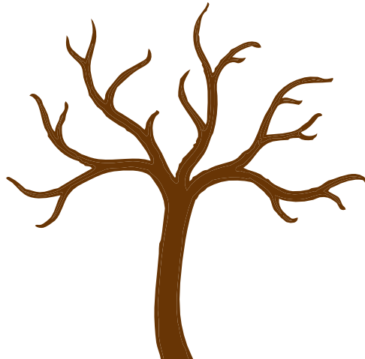

Name:____________________
Can you put the correct number of leaves on your tree?
2

Name:____________________
Can you put the correct number of leaves on your tree?
3

Name:____________________
Can you put the correct number of leaves on your tree?
4

Name:____________________
Can you put the correct number of leaves on your tree?
5

Name:____________________
Can you put the correct number of leaves on your tree?
6

Name:____________________
Can you put the correct number of leaves on your tree?
7

Name:____________________
Can you put the correct number of leaves on your tree?
8

Name:____________________
Can you put the correct number of leaves on your tree?
9

Name:____________________
Can you put the correct number of leaves on your tree?
l0

Name:____________________
Can you put the correct number of leaves on your tree?
ll

Name:____________________
Can you put the correct number of leaves on your tree?
l2

Name:____________________
Can you put the correct number of leaves on your tree?
l3

Name:____________________
Can you put the correct number of leaves on your tree?
l4

Name:____________________
Can you put the correct number of leaves on your tree?
l5

