**(Delete this before printing)**

1. Fold this front cover in half. For all the other pages, cut them up so that they are A5 size. Place the middle pages in the cover and staple along the spine to make your book.
2. Children are to find objects that are of a particular texture and then make a rubbing of it.

(This file is saved as a Word Doc so that you can add more pages).

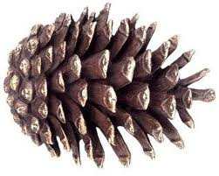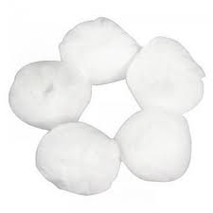

______________________________________

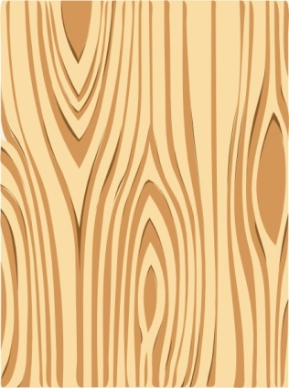Sensory book

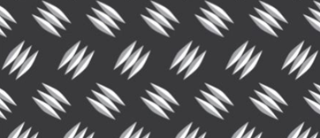

bumpy

smooth

rough

hard

soft